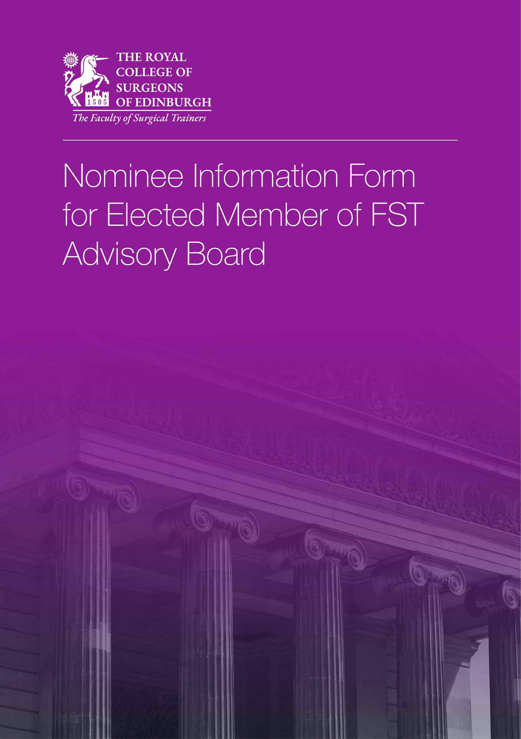

Nominee Information Form for Elected Member of FST Advisory Board
Associate / Member / Fellow representative

Please complete this form and return to fst@rcsed.ac.uk by 10:00 on Friday 2 July 2021.

Full Name
Title
College Reference No.
Login to your RCSEd Account and select ‘My Profile’ to find your CRN.
Home Address
Work Address
Phone
Email
Title Of Current Post
Specialty Interest
Key Management Roles
Committee Work
Training and Education Roles
Research and Clinical Work
Key Areas of Interest in Supporting Professional Activities
Contributions to the FST/RCSEd: Examiner, Committees, etc.

Supporting Statement

Please outline your aspirations for the future regarding involvement with the Faculty of Surgical Trainers / RCSEd. (500 words maximum)

Probity Declaration

I declare that I have not, in the UK or outside:
- Been convicted of a criminal offence (including any spent convictions) or have proceedings pending against me.
- Been subject to disciplinary proceedings, reprimand or suspension by the General Dental Council in the United Kingdom or any equivalent Regulatory or Licensing Body elsewhere.
- Been erased from the Register of the relevant registering body or failed to comply with conditions or qualifications imposed by the relevant registering body under performance review procedures.
- Had any disciplinary actions taken against me by an employer or contractor or have had any contract terminated or suspended on grounds relating to my fitness to practice.

Consent

I consent to this nomination.

Signature:

Date:

Please e-mail your completed nominee information form and a signed nomination form to fst@rcsed.ac.uk by 10:00 on Friday 2 July 2021.

Further information:
If you have any queries, please contact the Faculty of Surgical Trainers at fst@rcsed.ac.uk

By submitting this application, you understand that RCSEd will process your personal data in accordance with the terms of the General Data Protection Regulation (GDPR).

For the purposes of this election any personal data you provide will be shared with the Associates, Members and Fellows of the Faculty of Surgical Trainers of the Royal College of Surgeons of Edinburgh to enable voting and with Civica Election Services (CES). You can read their Privacy, Security and Copyright Statement at https://secure.cesvotes.com/V3-1-0/rcsed2021/en/policystatement

We will not share your data with any third party unless there is a statutory requirement for us to do so or unless we require to do so to deliver our services. Such sharing will only be undertaken where the appropriate Data Processing Agreements are in place and for tightly controlled purposes. The College will retain your data for the periods of time described in our privacy statement. Further details may be found on our website at https://www.rcsed.ac.uk/privacy.

