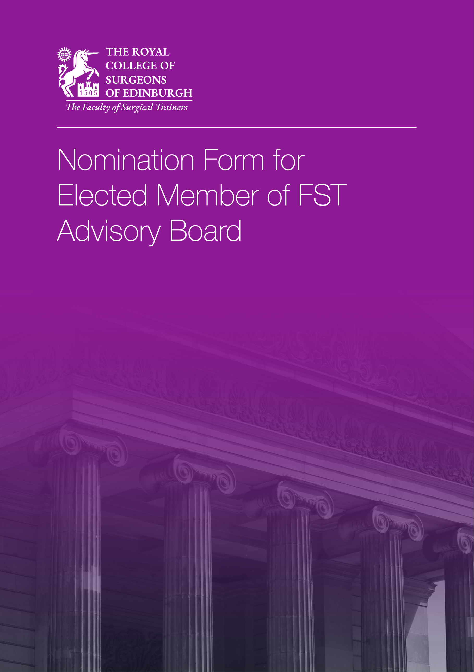

Nomination Form for Elected Member of FST Advisory Board
Associate / Member / Fellow representative

We, the undersigned members of the Faculty of Surgical Trainers of the Royal College of Surgeons of Edinburgh hereby nominate as an Associate/Member/Fellow (delete as applicable) representative on the Advisory Board of the Faculty of Surgical Trainers, their consent to this nomination having been obtained:

Proposer
Full Name
College Reference No. | Login to your RCSEd Account and select ‘My Profile’ to find your CRN.
Email
Signature |  | Date

Seconder
Full Name
College Reference No. | Login to your RCSEd Account and select ‘My Profile’ to find your CRN.
Email
Signature |  | Date

Please complete this form and return to fst@rcsed.ac.uk by 10:00 on Friday 2 July 2021.

For further information, please contact the Faculty of Surgical Trainers at fst@rcsed.ac.uk

By submitting this application, you understand that RCSEd will process your personal data in accordance with the terms of the General Data Protection Regulation (GDPR).

For the purposes of this election your name will be shared with Civica Election Services (CES). You can read their Privacy, Security and Copyright Statement at https://secure.cesvotes.com/V3-1-0/rcsed2021/en/policystatement

We will not share your data with any other third party unless there is a statutory requirement for us to do so or unless we require to do so to deliver our services. Such sharing will only be undertaken where the appropriate Data Processing Agreements are in place and for tightly controlled purposes. The College will retain your data for the periods of time described in our privacy statement. Further details may be found on our website at https://www.rcsed.ac.uk/privacy.

